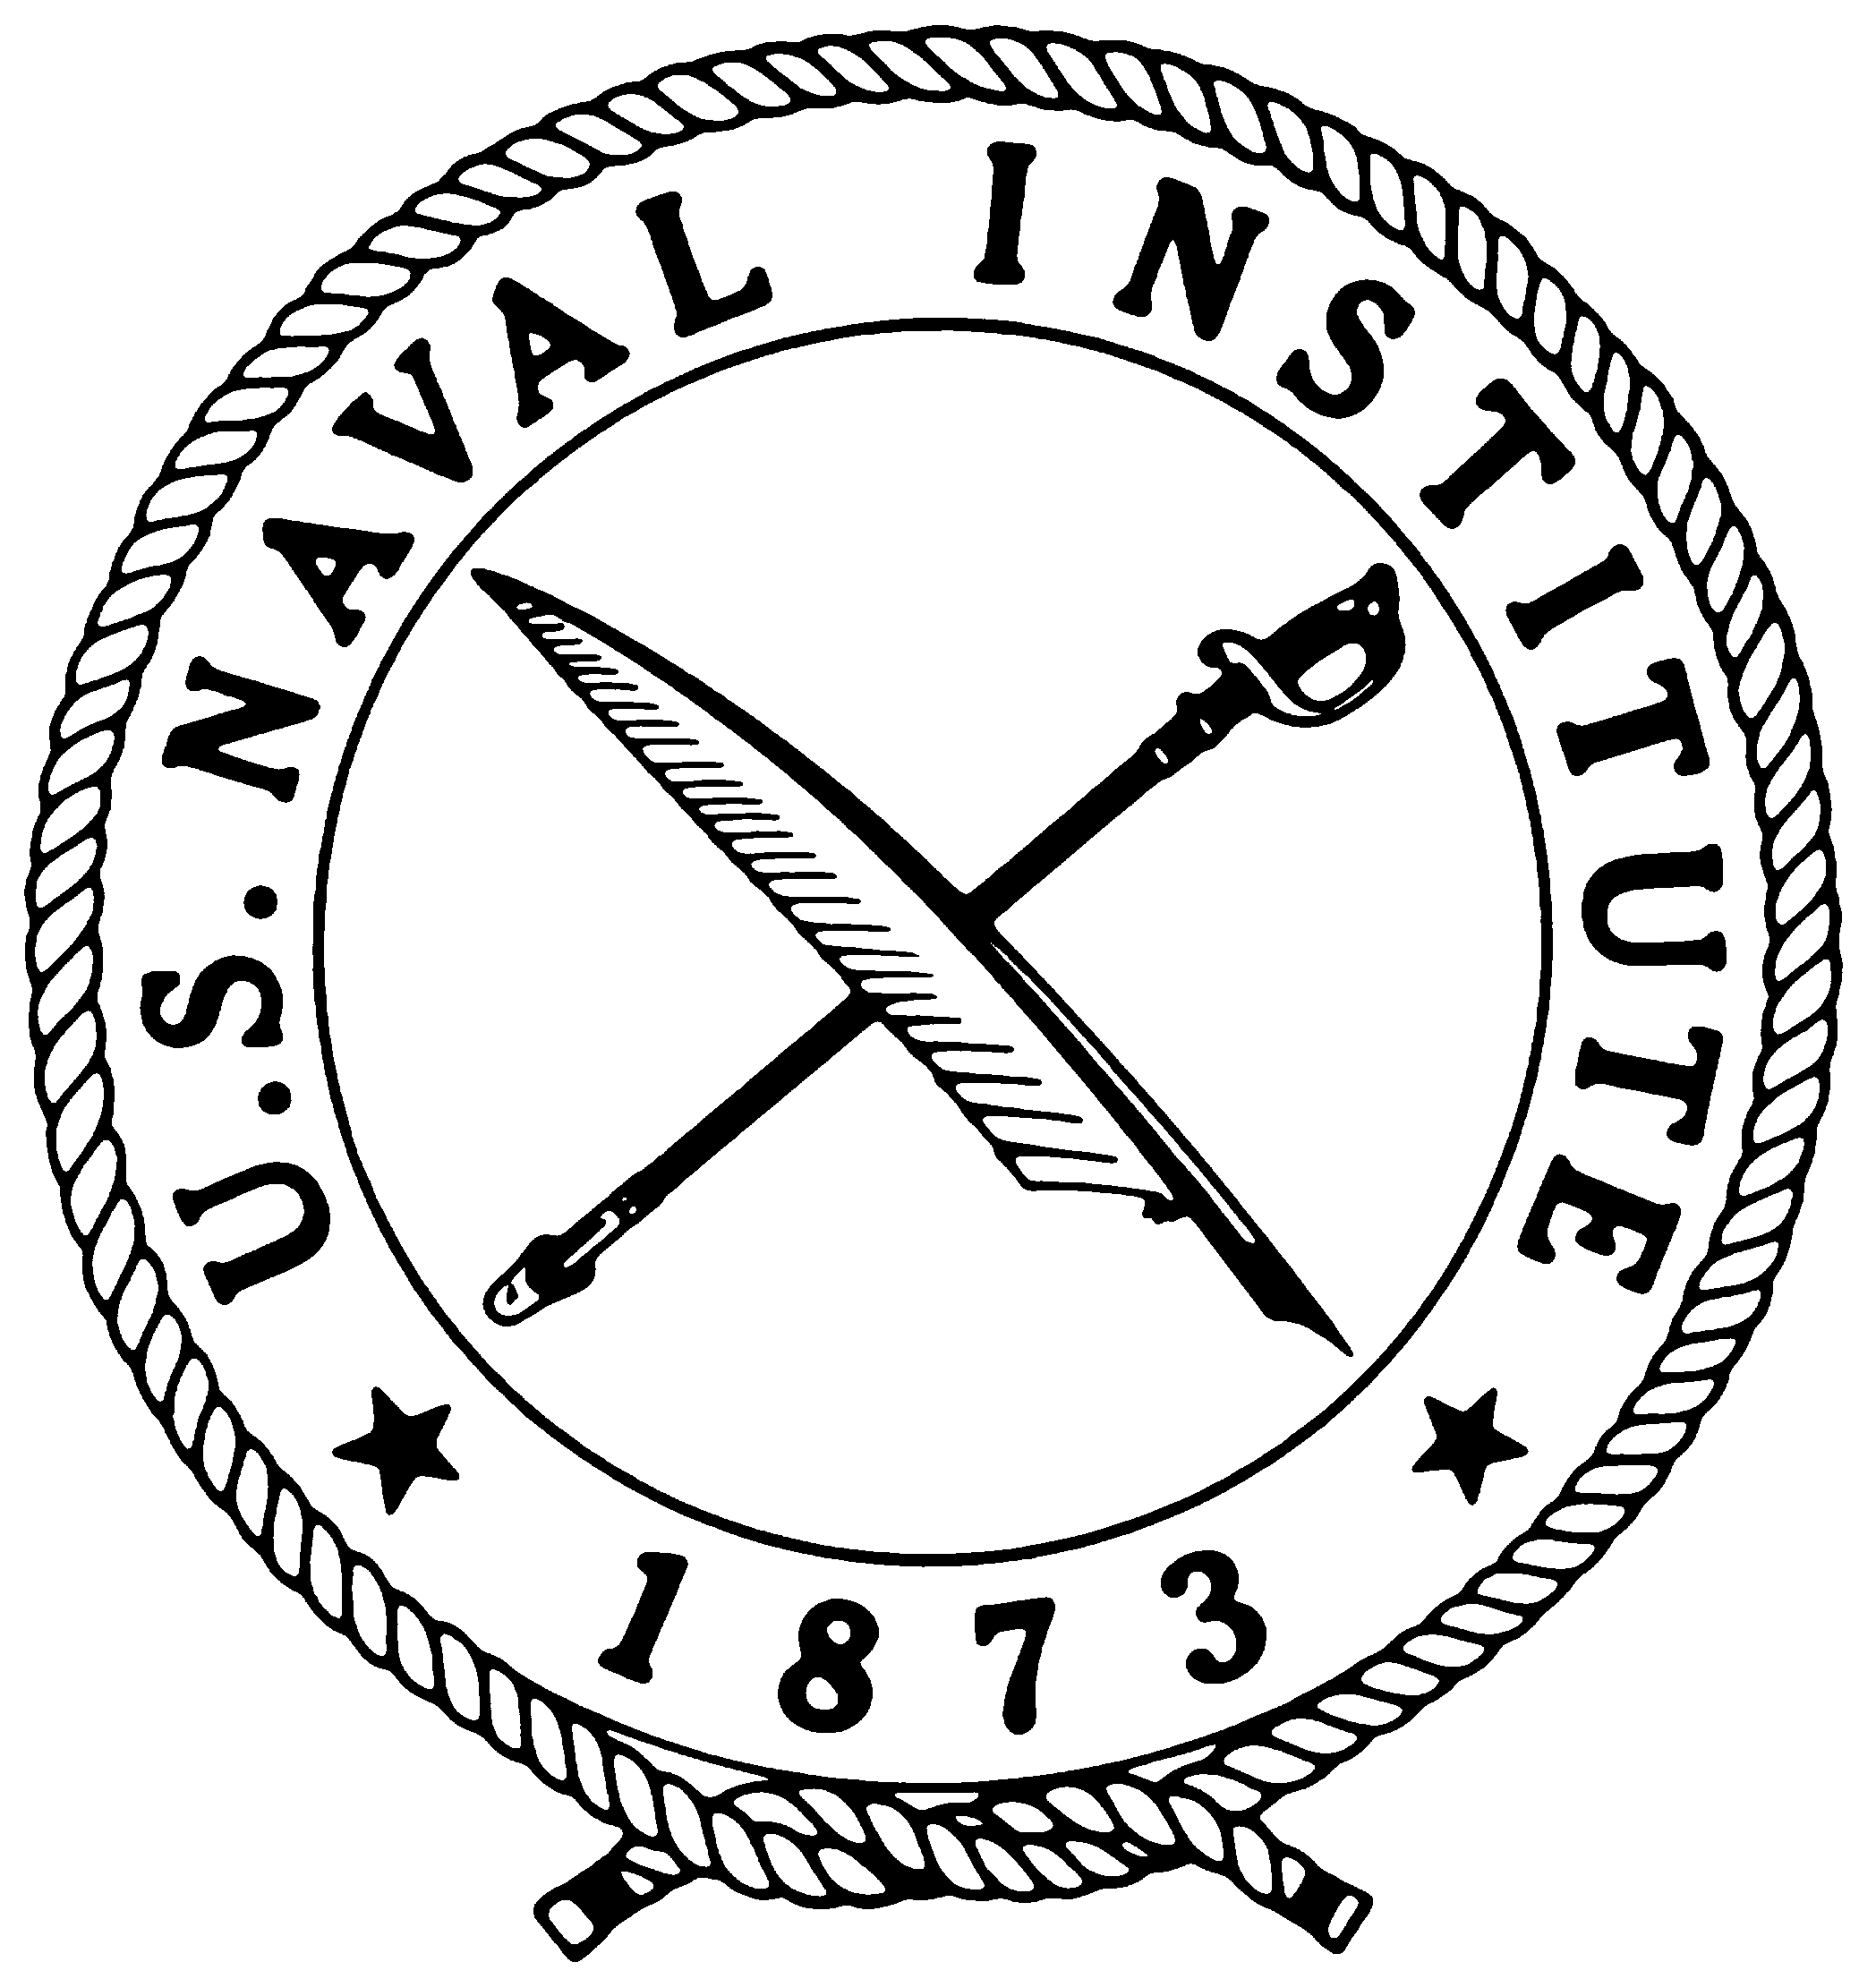
Naval Institute Press Book News

Chinese Aerospace Power

Evolving Maritime Roles

edited by Andrew S. Erickson and Lyle J. Goldstein
—Advance praise—

“China’s air and space development is an area of significant interest for the U.S. Navy. This book elucidates the critical linkage between China’s military aerospace and maritime capabilities. Whereas China’s rapid progress has already rendered many studies obsolete, this volume connects the latest ‘data point’ dots and puts them in strategic context. Navy leaders and planners should read it today.”
—Adm. Timothy J. Keating, USN (Ret.), former Commander-in-Chief, U.S. Pacific Command

“Erickson and Goldstein provide us with a comprehensive survey of China’s ongoing efforts to shift the military balance in the western Pacific decisively in its favor through the development and application of aerospace power as it pertains to the maritime competition. Drawing upon primary research and Chinese sources, this volume will be valuable and timely for those with an interest in this issue of growing geostrategic importance.”
—Andrew F. Krepinevich Jr., president of the Center for Strategic and Budgetary Assessments and author of 7 Deadly Scenarios: A Military Futurist Explores the Changing Face of War in the 21st Century

“Chinese Aerospace Power arrives on the scene as the United States is facing declining resources for defense, while China is realizing rapid expansion of its military capabilities in the aerospace and maritime domains. Erickson and Goldstein offer timely insight into how these two trends are evolving in these arenas. Resolving the security objectives of the U.S. and China in the Pacific—and around the world—requires that policymakers and military strategists understand the reality of Chinese military capabilities, experiences, and perspectives. This work provides that insight and is a must read as Chinese aerospace development is significantly altering the character of the military and political balance in the Pacific.”
—Lt. Gen. David A. Deptula, USAF (Ret.), former U.S. Air Force Deputy Chief of Staff for Intelligence, Surveillance, and Reconnaissance

“Serves well as an introduction to advances in Chinese maritime aerospace technology, and will also reward experts looking for the latest update on these evolving capabilities. Many readers will be surprised by the extent of Chinese progress described by the contributors to this work. They detail the strategic and technical issues that are shaping the Chinese military establishment as it looks beyond the country’s shores, and examine how it will develop in coming years and decades.”—Bradley Perrett, Asia-Pacific bureau chief, Aviation Week, Beijing

China’s aircraft carrier program is already making major waves well before the first ship has even been completed. Undoubtedly, this development heralds a new era in Chinese national security policy. While Chinese Aerospace Power presents substantial new insight on that particular question, its main focus is decidedly broader in scope. This book offers a comprehensive survey of Chinese aerospace developments, concentrating on areas of potential strategic significance previously unexplored in Western scholarship. It also links these developments to the vast maritime battlespace of the Asia-Pacific region and highlights the consequent implications for the U.S. military, particularly the U.S. Navy.
The possibility of a future Chinese expeditionary force operating off Africa under the protective umbrella of carrier aircraft is not without consequence for the global strategic balance. However, a simpler set of aerospace systems, from microsatellites to unmanned aerial vehicles to ballistic and cruise missiles, is already challenging U.S. maritime dominance in East Asia. Cumulatively, progress in all major aerospace dimensions by various elements of the People’s Liberation Army Navy (PLAN) signifies a new period in which Chinese forces are now decidedly altering the complexion of the military balance in the East Asian littoral.
While many articles and books have previously been written on Chinese aerospace development and many more discuss future U.S. naval strategy in the Asia-Pacific region, no other book connects the two issues, simultaneously evaluating the Chinese aerospace challenge and its implications for U.S. naval strategy

This volume is the fifth in the series, “Studies in Chinese Maritime Development” ~
- China’s Future Nuclear Submarine Force (ISBN: 978-1-59114-326-0)
- China’s Energy Strategy: The Impact on Beijing’s Maritime Policies
(ISBN: 978-1-59114-330-7)
- China Goes to Sea: Maritime Transformation in Comparative Historical Perspectives
(ISBN: 978-1-59114-242-3)
- China, The United States and 21st-Century Sea Power: Defining a Maritime Security Partnership (ISBN: 978-1-59114-243-0)

Andrew S. Erickson is an associate professor in the U.S. Naval War College’s Strategic Research Department and a founding member of its China Maritime Studies Institute (CMSI). He is an associate in research at Harvard University’s Fairbank Center for Chinese Studies and a fellow in the National Committee on U.S.-China Relations’ Public Intellectuals Program.

Lyle J. Goldstein is an associate professor in the U.S. Naval War College’s Strategic Research Department and the founding director of the department’s CMSI. He is proficient in Chinese and Russian and has published widely in scholarly journals on China, Russia, Central Asia, and surface and undersea warfare.
Chinese Aerospace Power: Evolving Maritime Roles
Edited by Andrew S. Erickson and Lyle J. Goldstein
Publication date: 15 July 2011. 544 pages. 4 maps. Index.
Hardcover. ISBN: 978-1-59114-241-6 / List price: $52.95

AT BOOKSTORES, MEDIA INQUIRES & REVIEW IN ENGLAND AND
ONLINE, OR DIRECT: COPIES, CONTACT: EUROPE, CONTACT:
Customer Service Judy Heise, Publicist Casemate Publishing
U.S. Naval Institute Naval Institute Press 17 Cheap Street
291 Wood Road 291 Wood Road Newbury, Berkshire
Annapolis, MD 21402 Annapolis, MD 21402 RG14 5DD U.K.
800-233-8764/410-268-6110 410-295-1028 / Fax: 410-295-1084 Tele: 011-44-1635 231091
www.usni.org jheise@usni.org www.casematepublishing.co.uk
The World’s Leading Naval and Military Publisher since 1898. Online at www.nip.org.

